

*Department of Computer Science and Engineering*

United International University

|  |  |  |  |
| --- | --- | --- | --- |
| SL | ID | Section | Name |
| 1 | 011143138 | C | Sakib Sahriar Khan |
| 2 | 011143120 | C | Akib Bhuia |
| 3 |  |  |  |
| 4 |  |  |  |

*Project Members*

*Team ID: FL16DB08*

*Project Report:*

*Database Management System Laboratory*

*Fall - 2016*

*Project Name:*

*Cycle Record and Management*

# Project Description:

# We are trying to build a online based system regarding bi-cycle. Trying to create and maintain a database of stolen bikes, so buying used bi-cycle will be more convenient. As well as the stole ratio of bi-cycle will hopefully drop by its usage. Besides, we are trying to launch a platform for trade, which will be only bi-cycle oriented.

# 

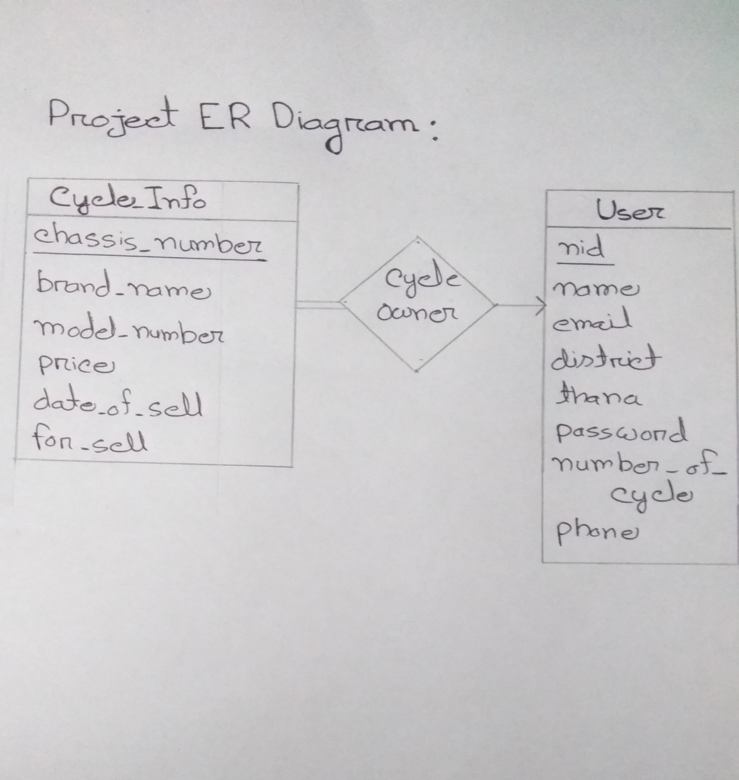

# Project Features:

# Owner’s profile.

# Owner’s Cycle information.

# Cycle sell and buy platform

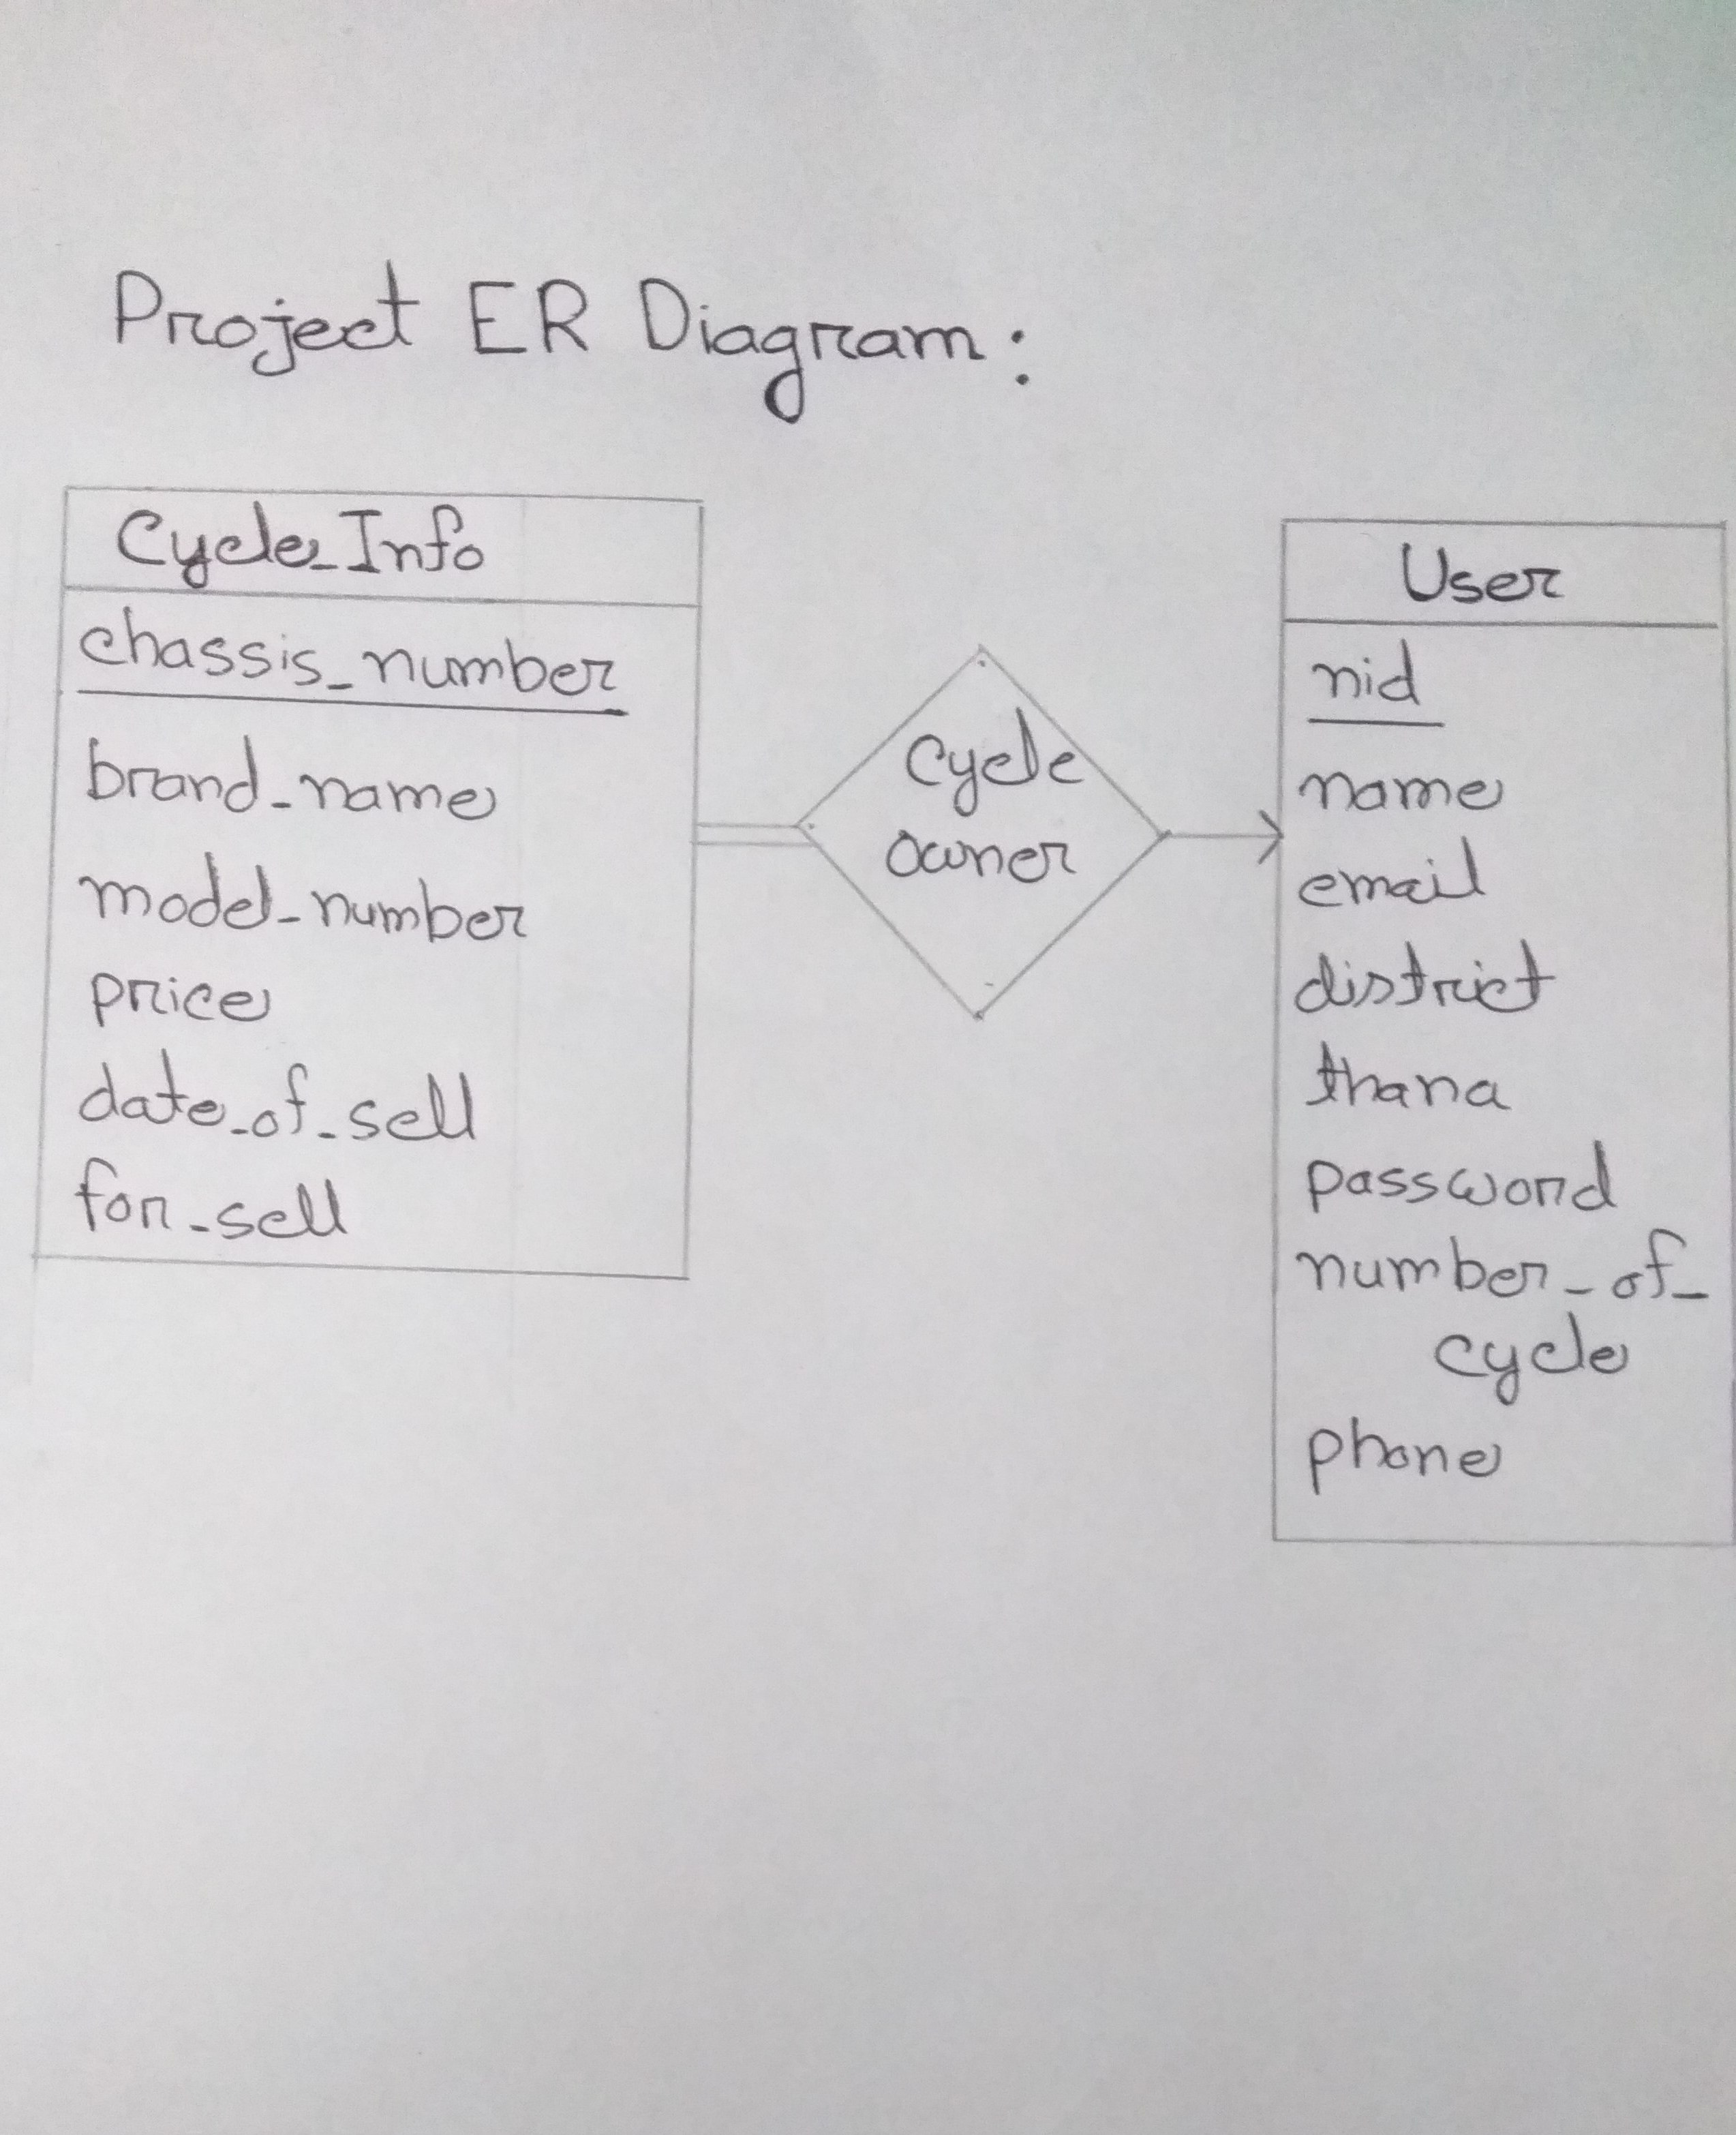

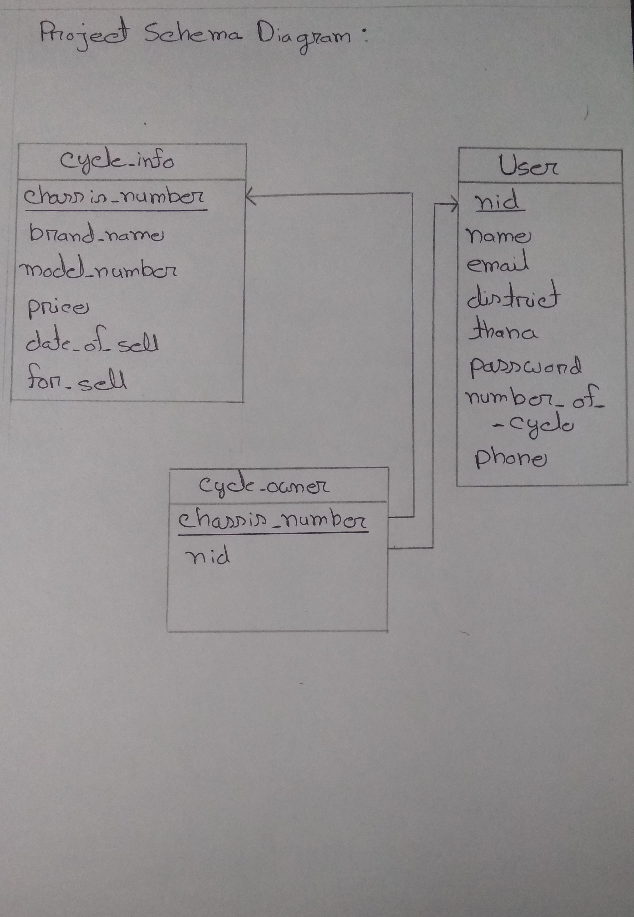5. Source of Database

create table cycle_info

(

chassis_number varchar(30) not null unique ,

brand_name varchar(30),

model_number varchar(30) not null,

price numeric(10,2) check (price > 0) ,

date_of_sale char(20) ,

for_sale int(1) not null ,

primary key(chassis_number)

);

create table user

(

nid varchar(15) not null unique ,

name varchar(20) not null,

email varchar(50) not null unique,

district varchar(15) ,

thana varchar(15) ,

password varchar(20) not null ,

number_of_cycle numeric(3,0) ,

phone varchar(30) not null,

primary key(nid)

);

create table cycle_owner

(

chassis_number varchar(15) not null unique ,

nid varchar(15) not null ,

primary key(chassis_number),

foreign key(chassis_number) references cycle_info(chassis_number),

foreign key(nid) references user(nid)

);

# Screenshots:

# C:\Users\Akib\Desktop\06.PNGC:\Users\Akib\Desktop\01.PNG

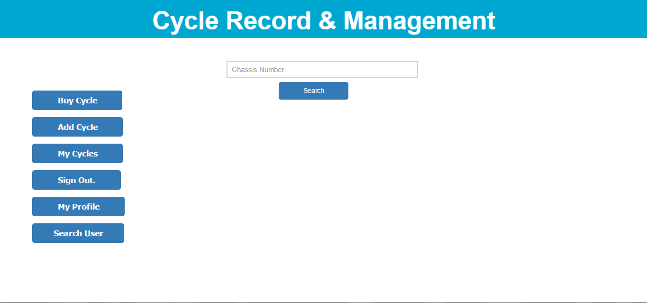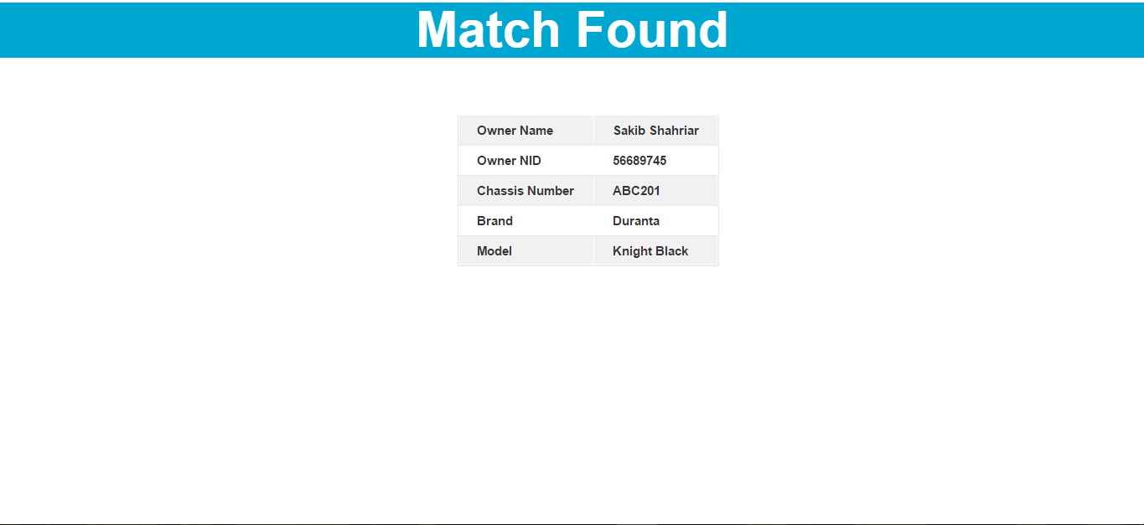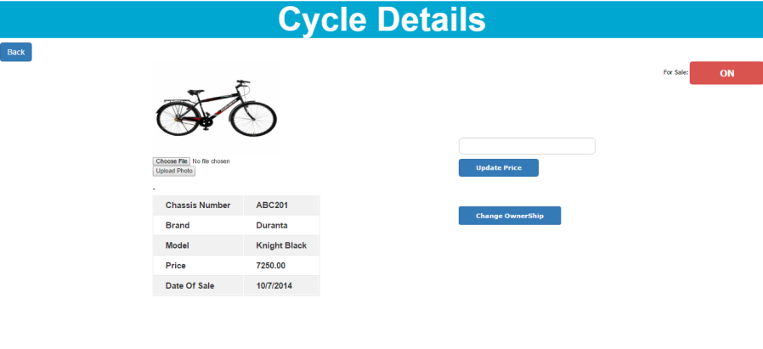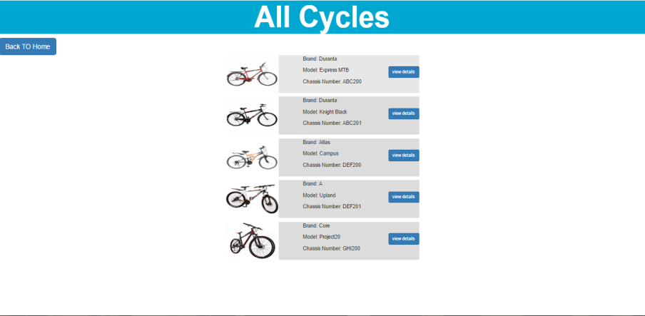

# Conclusions

# We will add Admin Panel to overcome fake user’s problem. As we are trying to launch a platform for trade, which will be only bi-cycle oriented we are planning to import something big with this system. Our plan is to provide a GPS tracking system as a additional feature.